# Task P3.1.2

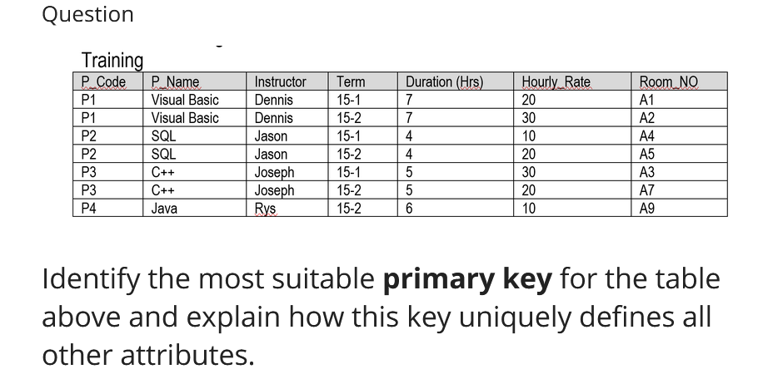

Answer:

**Combination of “P_Code” and “Room_NO”**

In this example each Room_NO is unique but, for the larger datasets there can be **repetition** in Room_NO as well so to make each primary key unique (for the larger dataset as well) I choose the Combination of “P_Code” and “Room_NO”.

Secondly, the primary key should be something which is **most efficient to search** through like an integer but in this case, it is not possible so I choose attribute with least amount of alphabets in it to make the process of querying database quicker .

Primary key must not contain any null values, and this combination exclude that possibility as well for larger dataset.